Central Norfolk St Georges Day Parade and Service

We have manged to finalise details for the St Georges Day.

We are planning to meet up at Swaffham Community Centre, Campingland, Swaffham PE37 7RB (Iceni Partnership).

2.30 pm - Ready to start forming up on the grass to the side of the centre

2.45 pm - Set off on the short parade to the Church

3 pm – Arrive into the Church, start service. After the young people have entered the church then parents, carers or supporters will be allowed to fill up extra spaces.

4.30pm – Finish Church Service, I hope we can then provide tea and biscuits

Please note the parade is quite short and it will follow this route.
Can you please pass to parents there is only limited parking at the Community Centre so the Theatre Street Carpark should be used.

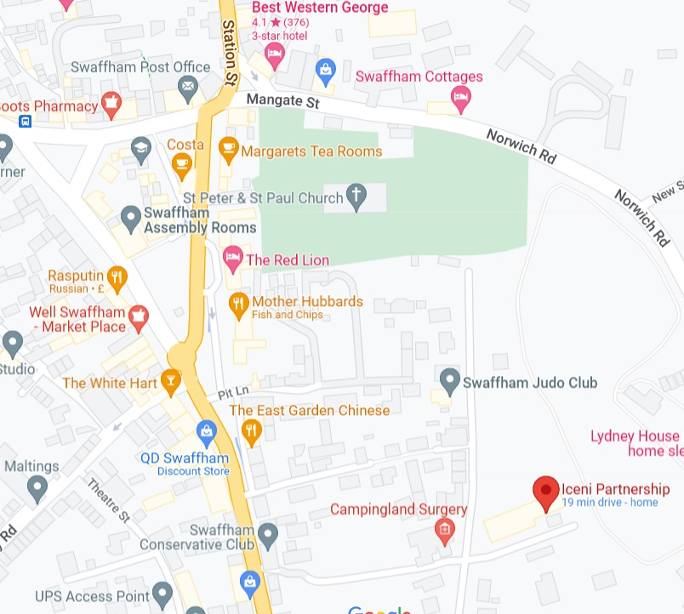
Form up area.
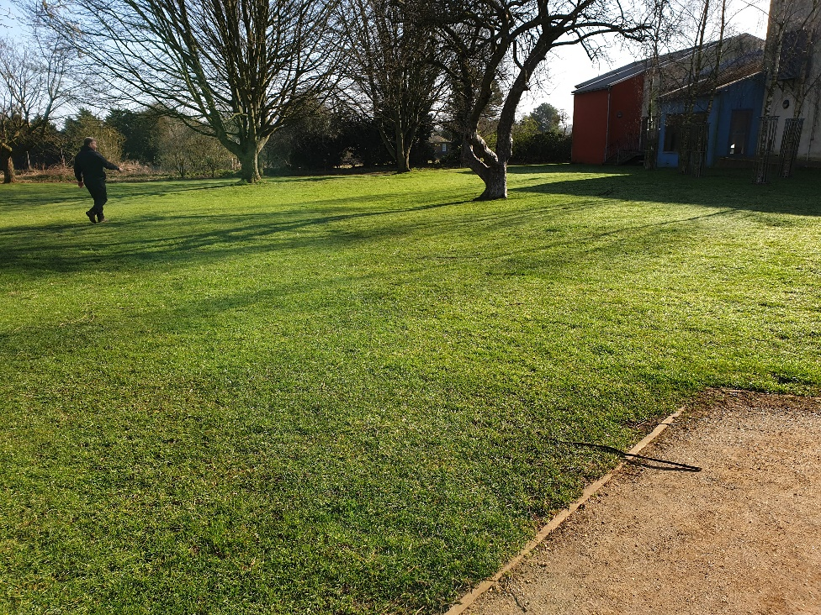
There will be group signs. Each group is to form up behind their marker.

Parade Set off
The group will follow on from the last group and go through this gap (form up 3 wide). This road will be a good place for parents to view the parade. Also note there will be no saluting during the parade.
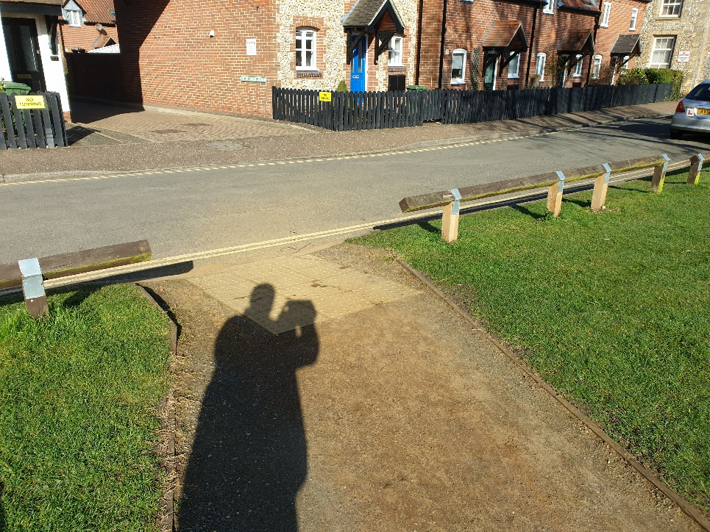

At the top of Camping Land road turn left towards Church

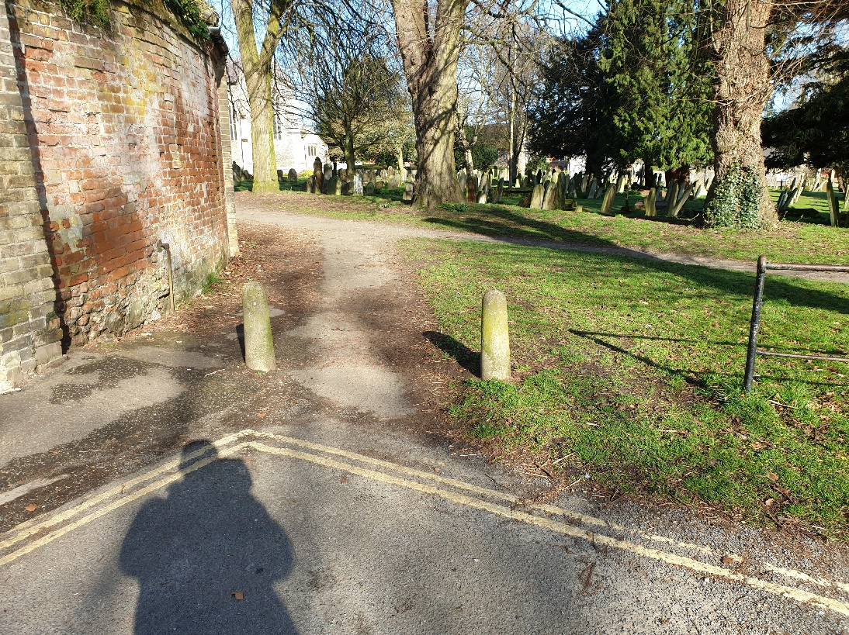

This is the worst part of the route we will have to fit through this gate.
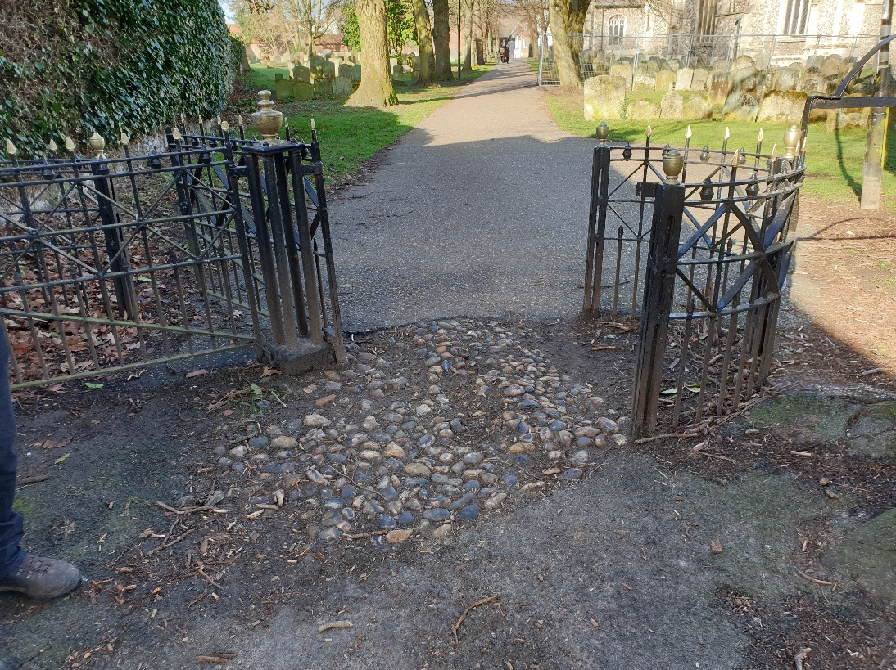

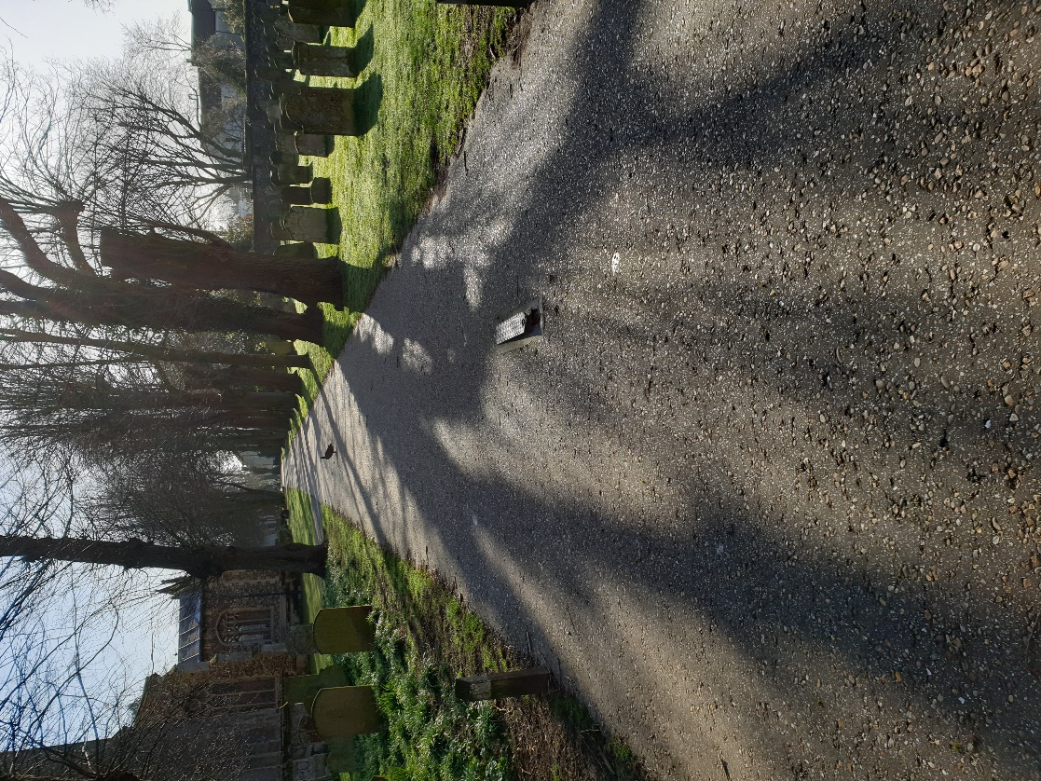
We then go straight along the Church path.

The parade will halt in front of the Bollards

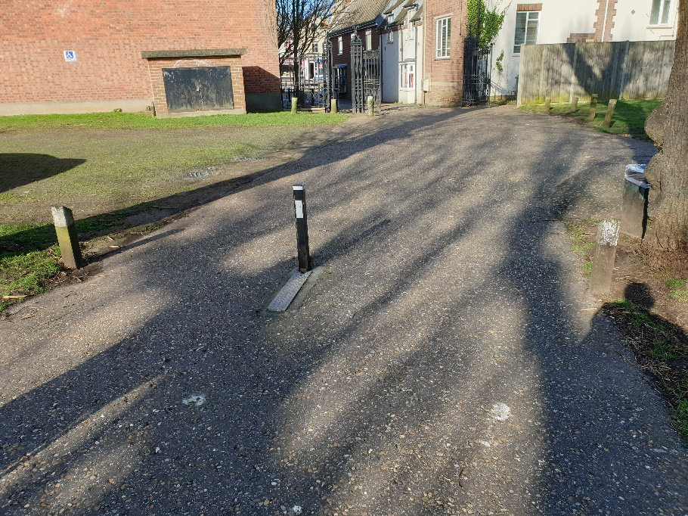

Once at halt the command of fall out of the standards will be given and all of the Flag bearers should move to the front to form up at the entrance of the church.

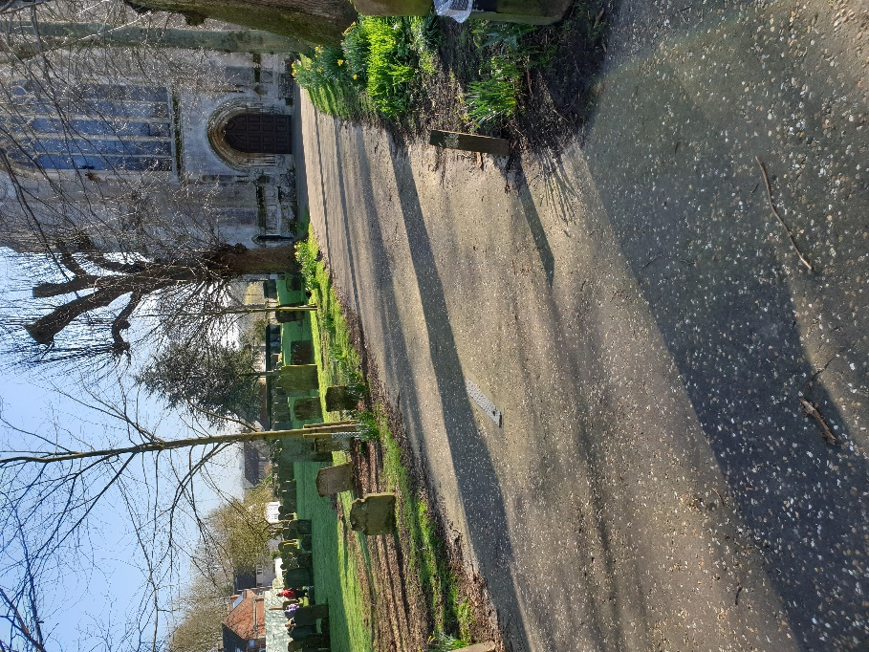

Once the flags are in place the parade will then enter the church

During the service a collection will be taken and will be donated to the Scouts of Ukraine.

